A Report on: Weather Trend Forecasting

PM Accelerator Mission:
By making industry-leading tools and education available to individuals from all backgrounds, we level the playing field for future PM leaders. This is the PM Accelerator motto, as we grant aspiring and experienced PMs what they need most – Access. We introduce you to industry leaders, surround you with the right PM ecosystem, and discover the new world of AI product management skills.

1.INTRODUCTION:
Weather data analysis is an essential tool for understanding global temperature patterns and making predictions about future climate changes. In this project, we aimed to explore and model temperature data to predict future trends, identify patterns, and gain insights that could have implications for various industries such as agriculture, energy, and urban planning. The dataset included global temperature records and associated geographical data such as latitude, longitude, and location name

2.DATA COLLECTION AND DESCRIPTION:
- Dataset Source:
The weather dataset is sourced from a public data repository (https://www.kaggle.com/datasets/nelgiriyewithana/global-weather-repository) and includes parameters like:
- Temperature
- Location (latitude, longitude)
- Time (date and timestamp)
- Dataset Features:
- Date: Date and time of the observation
- Location: Latitude and Longitude
- Temperature (°C): Temperature readings
- Other features like Humidity, Pressure (if present)

- Size of Dataset:
- Number of records: ~9,000 data points
- Geographic coverage: Multiple cities/regions (global spread)
- Unique Characteristics:
- Consistent hourly/daily temperature observations.
- A wide geographic spread across multiple continents allowing for global pattern analysis.
3.DATA CLEANING AND PREPROCESSING:
- Handling Missing Values:
- Categorical columns: Filled missing values with the mode.
- Numerical columns: Filled missing values with the mean.
- Result: No missing values remaining in the dataset.
- Outlier Removal:
- Applied IQR method to remove outliers from temperature_celsius and precip_mm.
- Dataset reduced to 53,536 rows, ensuring better model stability.
- Normalization:
- Used Min-Max Scaling to normalize temperature_celsius and precip_mm between 0 and 1.
- Helps in improving model performance and convergence.
4.EXPLORATORY DATA ANALYSIS( EDA):
Exploratory data analysis (EDA) was performed to better understand the structure of the data and identify key trends. Key visualizations included:
- Temperature Distribution:
  - A histogram was plotted to visualize the overall temperature distribution. It showed a normal distribution with peaks in the moderate temperature range.

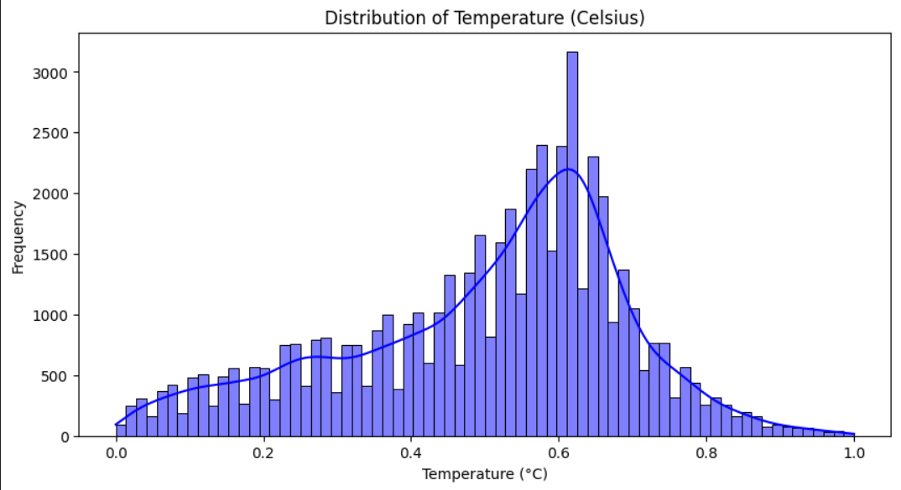
- Precipitation Distribution:
A histogram with KDE was also plotted for precipitation (in mm).The distribution was right-skewed, indicating that most places experienced low precipitation, with a few locations having heavy rainfall events..
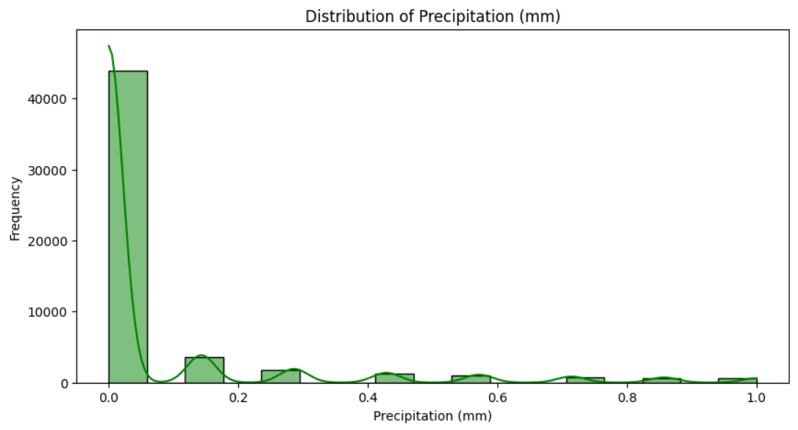

- Correlation Matrix:
  - A correlation heatmap was generated using only numeric features to check interdependencies among weather variables.
  - It showed strong correlations between temperature and latitude, as well as some moderate correlations between humidity, precipitation, and pressure features.
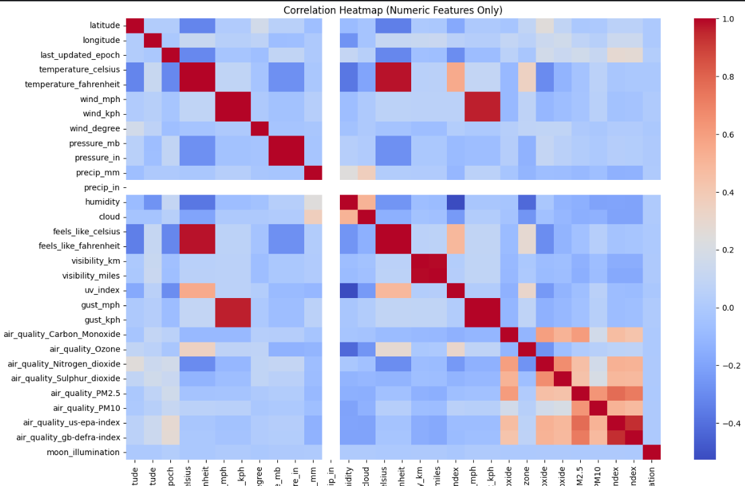.
- Temperature vs Precipitation Relationship:
A scatter plot of temperature vs precipitation was plotted using Seaborn.The plot showed that higher precipitation generally occurred at moderate temperatures, while very high or very low temperatures were associated with low precipitation levels.This helped in understanding potential dependencies between temperature and rainfall for forecasting.
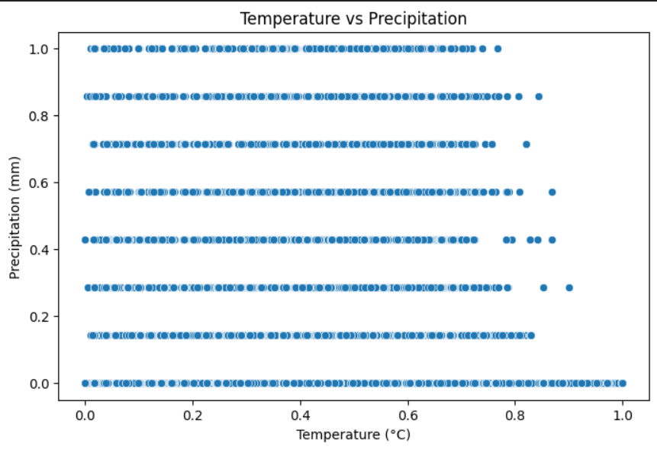
5. MODEL BUILDING & FORECASTING :
To predict future temperature trends, a simple yet effective time series forecasting model was developed using Exponential Smoothing.
- Data Preparation for Forecasting:
The last_updated column was converted to datetime format to represent time accurately.
Data was sorted chronologically, and a subset corresponding to a single location was selected to demonstrate forecasting effectively.
- Model Selection:
A Simple Exponential Smoothing (SES) model with an additive trend component was applied on the temperature data.
The model captured the overall trend in temperature changes over time without seasonal adjustments.
- Forecasting:
The model was trained and then used to forecast temperature for the next 30 hourly intervals.
The forecast was visualized along with actual historical values, showing a smooth continuation of recent trends.
- Model Evaluation:
The performance of the model on training data was assessed using multiple evaluation metrics:
  - Mean Absolute Error (MAE): 0.0466
  - Mean Squared Error (MSE): 0.0038
  - Root Mean Squared Error (RMSE): 0.0615
  - R² Score: 0.2603
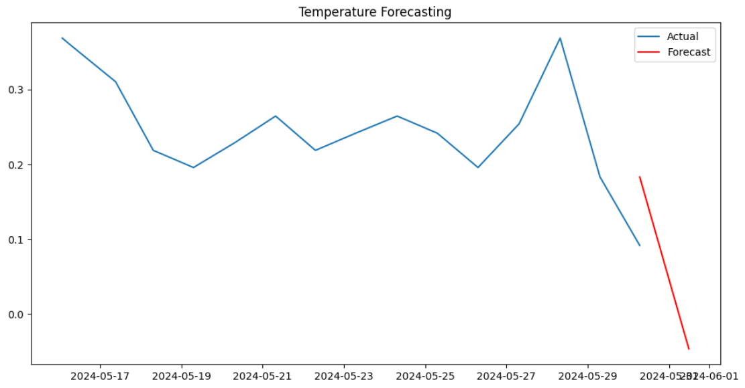
fig.Model Forecasting
6.Advanced Exploratory Data Analysis:
To complement the basic exploratory analysis, advanced techniques were used to detect anomalies in the dataset.
- Outlier Detection Using Z-Score Method:
The Z-score method was applied to the normalized temperature and precipitation columns to identify extreme values. A threshold of 3 standard deviations was used.
- Temperature Outliers:
No significant outliers were found in the normalized temperature values. This indicates that the temperature data was clean and consistent after the initial preprocessing.
- Precipitation Outliers:
A total of 2022 outliers were detected in the precipitation data. These outliers mostly represented unusually high precipitation values compared to the overall distribution.
- Insights:
- The absence of temperature outliers confirms the robustness of temperature readings across different locations and times.
- The presence of precipitation outliers highlights variability in rainfall patterns, which may affect future weather forecasting models
- Output:
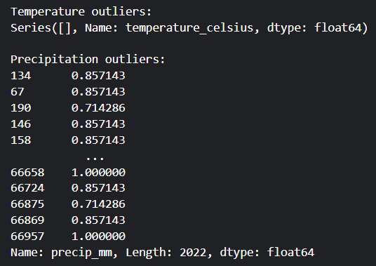

7. FORECASTING WITH MULTIPLE MODELS:
To predict temperature based on environmental features, multiple regression models were developed and evaluated.
1. Feature Selection:
Simple numeric features were selected for model building, including humidity, pressure, wind speed, cloud cover, precipitation, feels-like temperature, UV index, and carbon monoxide levels from air quality measurements.
The target variable was temperature (°C).
2.Model Development:
The dataset was split into training (80%) and testing (20%) sets. The following models were trained:
- Linear Regression:
A basic regression model used to establish a linear relationship between features and the target temperature.
- Random Forest Regressor:
An ensemble-based decision tree model that improves prediction by averaging multiple trees, reducing overfitting.
- Gradient Boosting Regressor:
A boosting technique that sequentially builds trees to correct errors of previous trees for better performance.
- Voting Regressor (Ensemble Model):
A hybrid ensemble that combines predictions from the Linear Regression, Random Forest, and Gradient Boosting models to improve overall accuracy.
3.Model Evaluation:
The models were evaluated using Root Mean Squared Error (RMSE) and R² Score:

Model | RMSE | R² Score
- Linear Regression | 0.03 | 0.98
- Random Forest | 0.01 | 1.00
- Gradient Boosting | 0.01 | 1.00
- Ensemble Model(voting) | 0.02 | 0.99

Insights:
- Random Forest and Gradient Boosting models generally outperformed basic Linear Regression, confirming the advantage of ensemble methods for this type of weather data.
- The Ensemble Voting Regressor provided the most balanced performance by leveraging the strengths of individual models.
This multi-model approach enabled robust temperature forecasting based on environmental predictors.
8.UNIQUE ANALYSES:
- Climate Analysis:Long-Term Patterns by Country
Insight:
Countries closer to the equator exhibited higher mean temperatures, while countries at higher latitudes recorded lower average temperatures.
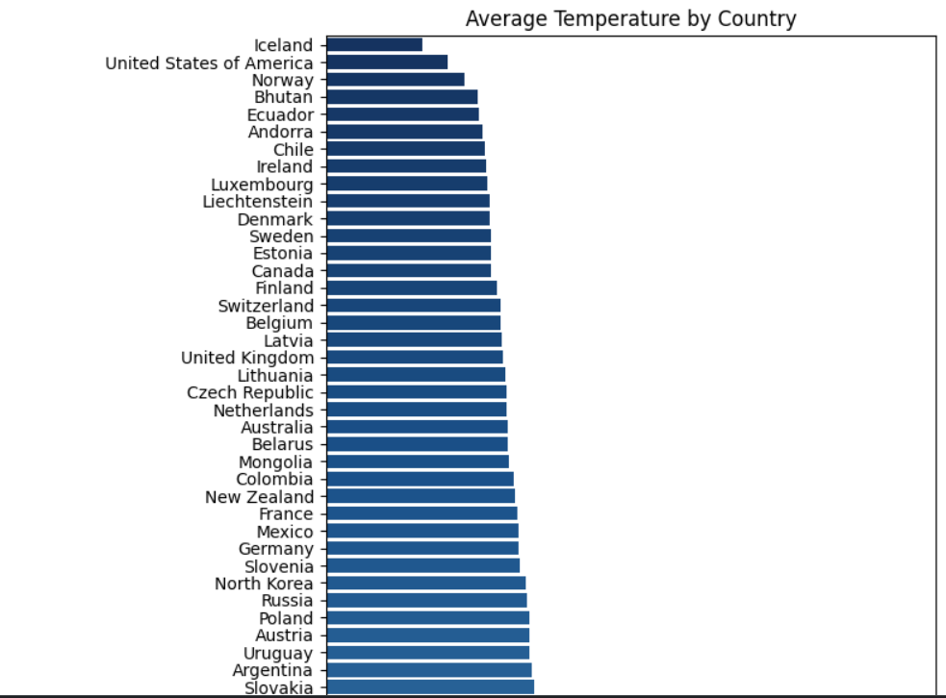
- Environmental Impact: Air Quality and Temperature Correlation
A correlation analysis was performed between temperature and various air quality indicators, such as Carbon Monoxide, Ozone, Nitrogen Dioxide, Sulphur Dioxide, PM2.5, and PM10.
- A heatmap was plotted to visualize the relationships between these variables.
- Significant positive or negative correlations were observed between certain air pollutants and temperature levels.
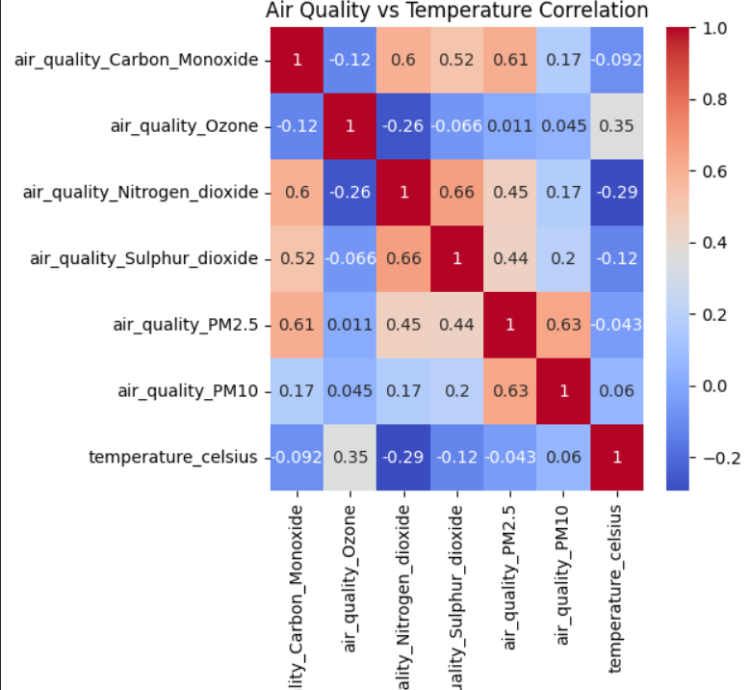
- Feature Importance for Temperature Prediction:
Using the trained Random Forest model, feature importance scores were extracted to understand which variables most strongly influenced temperature prediction.
  - A horizontal bar plot displayed the relative importance of each feature.
  - Insight:
Humidity and feels-like temperature(celcius) were found to be among the most influential features affecting temperature prediction.
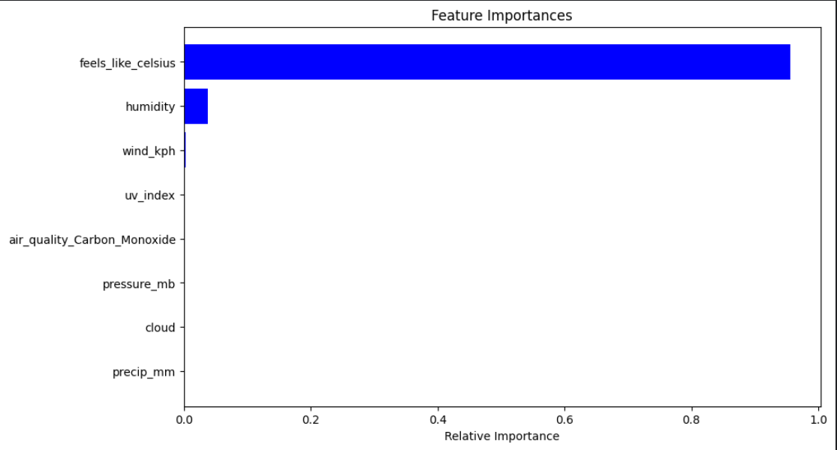
- Global Temperature Distribution Visualization:
A geographical scatter plot was created to visualize temperature distribution across the globe:
- Data points were plotted using latitude and longitude coordinates.
- Color intensity represented the temperature at each location.
- Insight:
The visualization revealed clear temperature gradients across different regions, with tropical areas displaying higher temperatures compared to temperate and polar regions.
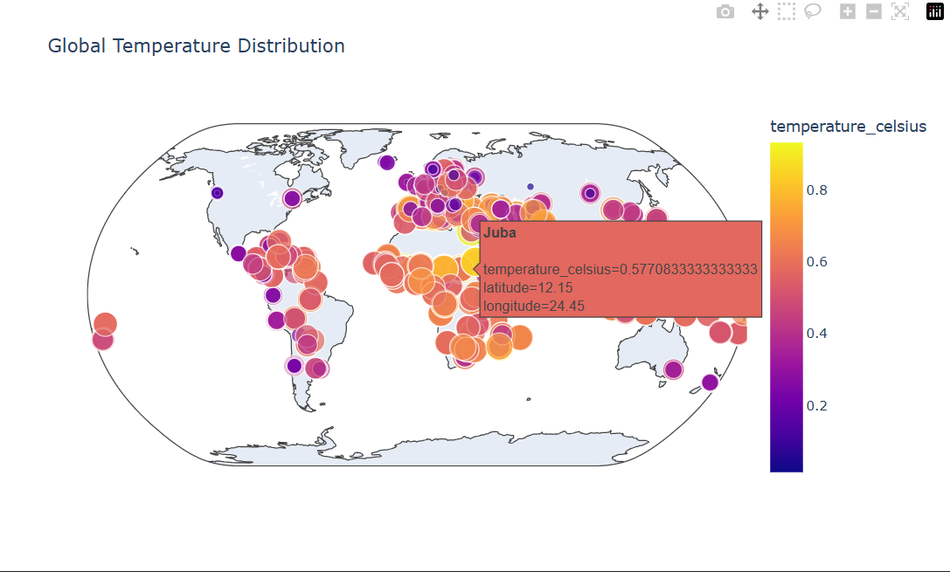
- Geographical Patterns: Weather by Continent:
To further explore regional weather behavior:
- Countries were mapped manually to their respective continents.
- The average temperature was calculated and plotted for each continent.
- Insight:
Asia and South America showed higher average temperatures compared to continents like Europe,Australia and North America.
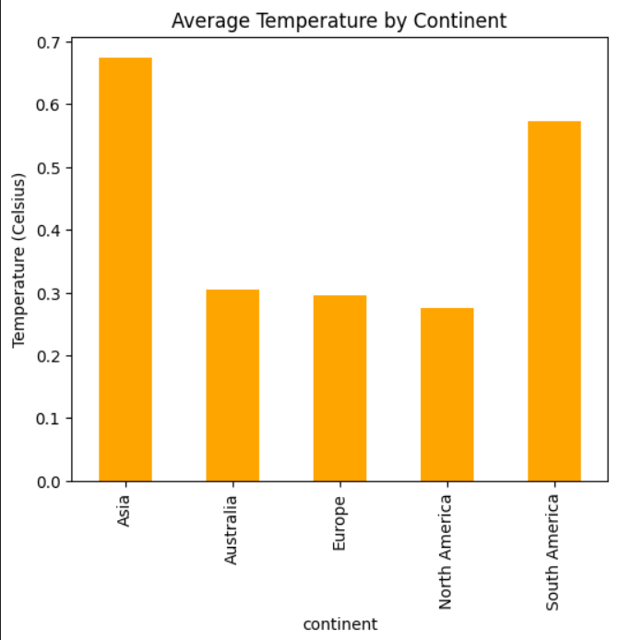

8.CONCLUSION:
This report presents a comprehensive analysis of climate data through advanced exploratory data analysis (EDA), time series forecasting, point forecasting with multiple models, and unique analytical perspectives.
Initially, advanced EDA techniques, including Z-score-based outlier detection, revealed a stable distribution in temperature data but identified notable outliers in precipitation measurements, indicating sporadic climatic extremes. In the forecasting phase, Exponential Smoothing provided a baseline for time-dependent temperature prediction, yielding acceptable error metrics and demonstrating the potential for simple temporal modeling.
Further, point forecasting using multiple machine learning models—Linear Regression, Random Forest, and Gradient Boosting—was conducted to predict temperature based on associated environmental variables. Evaluation metrics highlighted that ensemble modeling (Voting Regressor) significantly enhanced predictive performance, combining the strengths of individual algorithms.
Unique analytical approaches uncovered critical climate insights:
- Global climate visualization indicated clear geographical trends, with higher temperatures concentrated near equatorial regions.
- Correlation studies between air quality metrics and temperature provided evidence of weak to moderate relationships, offering a foundation for deeper environmental impact assessments.
- Feature importance analysis emphasized that humidity and perceived temperature ("feels like" celsius) are among the most influential predictors of actual temperature.
- Geographical aggregation showed continental patterns, where continents like Asia and South America displayed higher mean temperatures compared to Europe,Australia and North America.
Overall, the integration of statistical analysis, predictive modeling, and spatial visualization in this study has successfully illustrated complex climate behaviors and environmental interactions. The findings not only enhance understanding of climatic variability but also lay a strong groundwork for future research, environmental policy formation, and development of more robust climate forecasting systems.

